2652. Sum Multiples˙
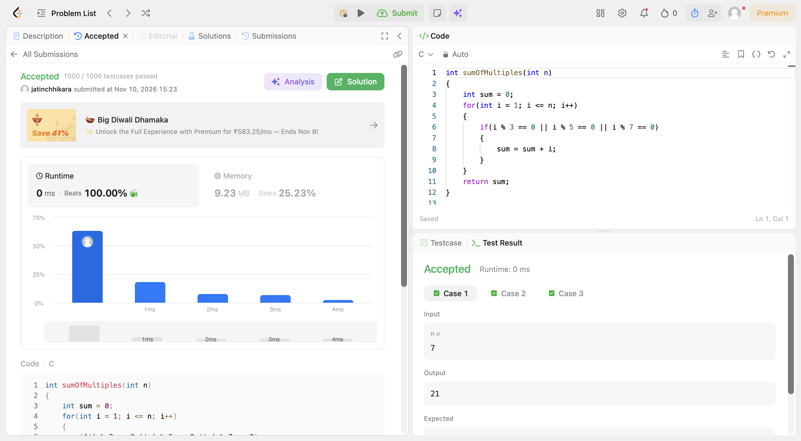
Code:
int sumOfMultiples(int n)
{
int sum = 0;
for(int i = 1; i <= n; i++)
{
if(i % 3 == 0 || i % 5 == 0 || i % 7 == 0)
{
sum = sum + i;
}
}
return sum;
}

